**1 Modélisation d'une paroi : Mur en pierres**

**1-1** Instrumentalisation du modèle :

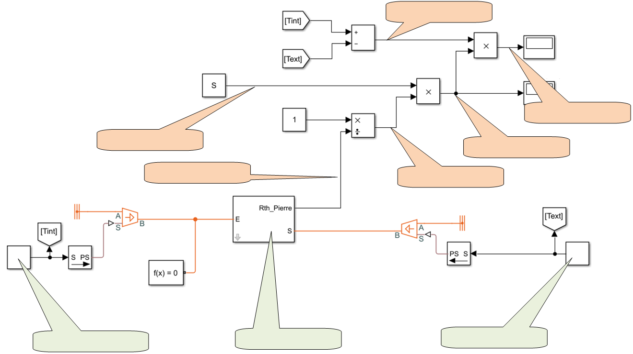

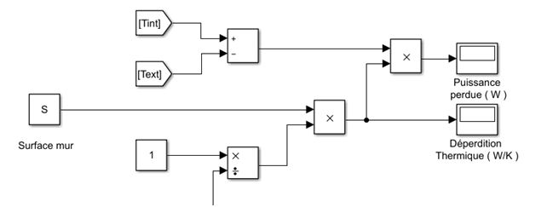

Rth

**1-2** Le modèle de la paroi :

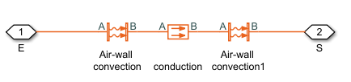

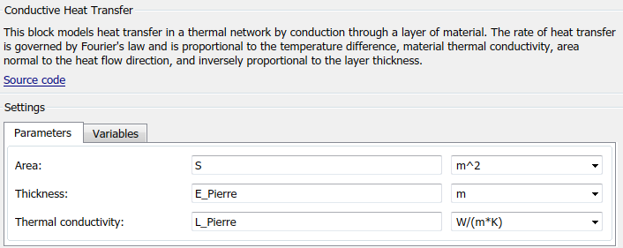

_ _ _ _ _ _ _ _ _ _ _ _ _ _ _ _ _ _ _ _ _ _ _ _ _

_ _ _ _ _ _ _ _ _ _ _ _ _ _ _ _ _ _ _ _ _ _ _ _ _

_ _ _ _ _ _ _ _ _ _ _ _ _ _ _ _ _ _ _ _ _ _ _ _ _

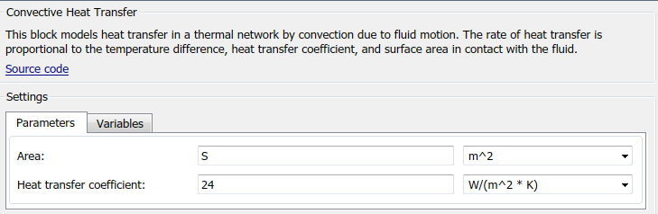

_ _ _ _ _ _ _ _ _ _ _ _ _ _ _ _ _ _ _ _ _ _ _ _ _

_ _ _ _ _ _ _ _ _ _ _ _ _ _ _ _ _ _ _ _ _ _ _ _ _

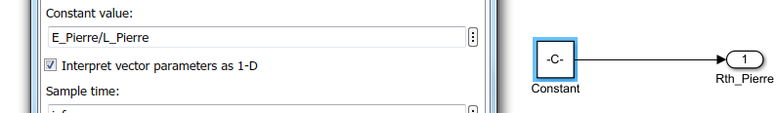

_ _ _ _ _ _ _ _ _ _ _ _ _ _ _ _ _ _ _ _ _ _ _ _ _

_ _ _ _ _ _ _ _ _ _ _ _ _ _ _ _ _ _ _ _ _ _ _ _ _

**1-3** La simulation :

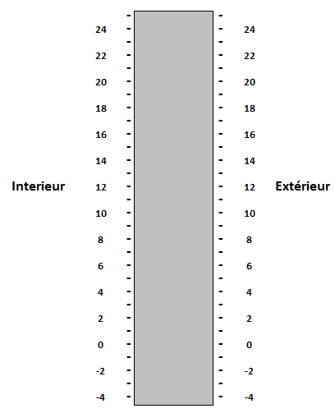

Déperdition =

Puissance perdue =

Epaisseur mur =

**λpierre =**

Surface =

**2 Modélisation d'une paroi : Mur en pierres avec isolation intérieure**

**2-1** Le modèle de la paroi :

Justification Modèle de mur : _ _ _ _ _ _ _ _ _ _ _ _ _ _ _ _ _ _ _ _ _ _ _ _ _ _ _ _ _ _ _ _ _ _ _ _ _ _ _ _ _ _ _ _ _ _ _ _ _ _ _ _ _ _ _ _ _ _ _ _ _ _ _ _ _ _ _ _ _ _ _ _ _ _ _ _ _ _ _ _ _ _ _ _ _

**2-2** La simulation :

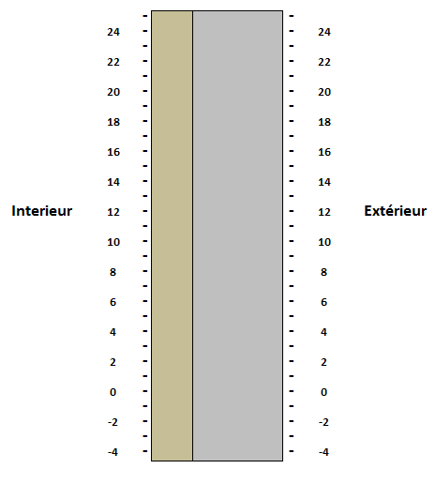

Déperdition =

Puissance perdue =

Epaisseur mur = **λpierre =**

Epaisseur Poly = **λpoly  =**

Surface =

**3 Modélisation d'une paroi : Mur en parpaings avec isolation intérieure**

**3-1** La simulation :

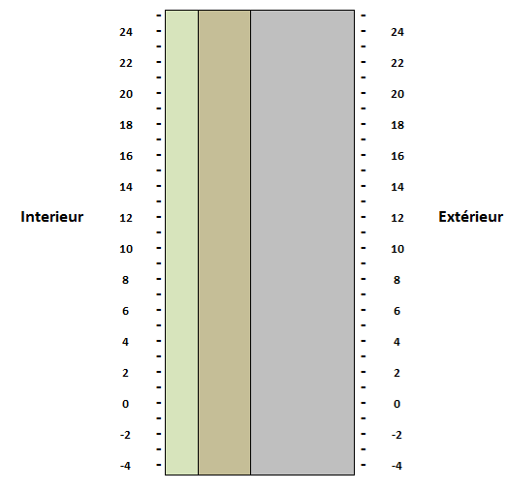

Déperdition =

Puissance perdue =

Epaisseur mur = **λmur =**

Epaisseur BA13 = **λba13  =**

Epaisseur laine R = **λlaine  =**

Surface =

**4 Modélisation d'une paroi : Mur et fenêtre**

**4-1** La simulation :

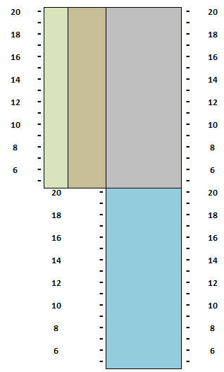

Déperdition =

Puissance perdue =

Epaisseur mur λmur =

Epaisseur BA13 = λba13  =

Epaisseur laine R = λlaine  =

Surface mur =

Epaisseur fenêtre = λfen =

Surface fenêtre =

**5 Conclusion :**

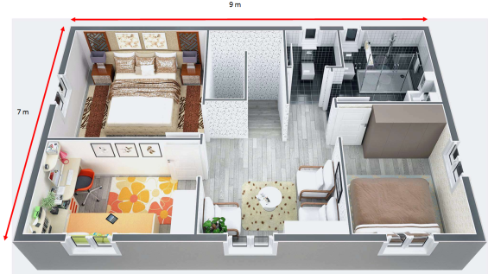

Surface des murs =

Surface de fenêtres =

Déperdition =

Puissance perdue =

Pertes financières =

**6 Modélisation du volume habitable:**

Puissance perdue =

Pertes financières =