# RÃ©sultat de recherche d'images pour "ordinateur"Chaîne d'information

COMMUNIQUER

TRAITER

ACQUERIR

# Chaîne d’information

# 

# 

# 

# 

# _ _ _ _ _ _ _ _ _ _ _ _ _ _ _ _ _ _ _ _ _ _ _ _ _

# Fonction Acquérir

**Curseur**

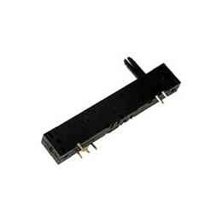

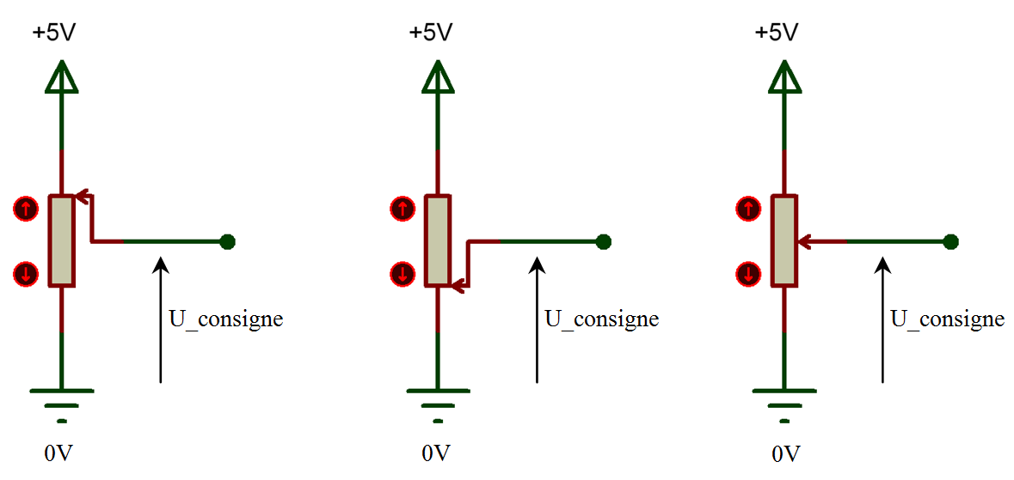

***Analyse :*** U_consigne = U_consigne = U_consigne =

***Mesures :*** U_consigne = U_consigne = U_consigne =

Grandeur Physique Grandeur Physique

ACQUERIR

_ _ _ _ _ _ _ _ _ _ _ _ _ _ _ _

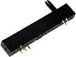

_ _ _ _ _ _ _ _ _ _ _ _ _ _ _ _

Loi d'entrée sortie

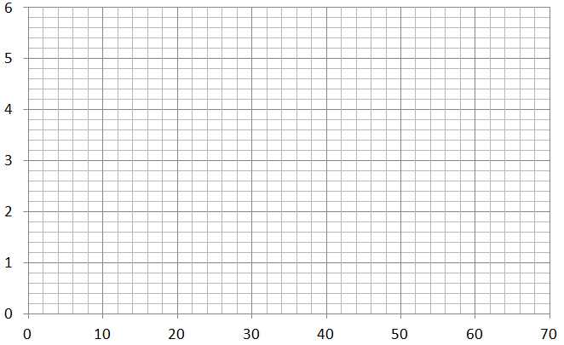

Equation :

# Fonction Traiter

CAN :

Largeur fissure

N_consigne

U_consigne

Traitement

CAN

TRAITER

**N_consigne** = **U_consigne** x (2**10**) -1

**5**

_ _ _ _ _ _ < **N_consigne** <_ _ _ _ _ _

Fissure :

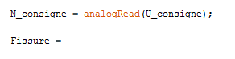

Précision :

# Fonction Communiquer

COMMUNIQUER

Première :

Dernière ligne :

# 

Adresse IP utilisée :

Alerte :



                        

                        

                        

                        

                        

                        

                        

                        

                        

                        

                        

                        